PART I Download and Install MS SQL Server 2008

To use MS SQL Server and its database, one needs to download the server software and server management software. Fortunately, Microsoft provides a free version of SQL Server – MS SQL Server 2008 Express, which has the full functionality of the standard MS SQL Server.
One needs complete the following steps to finish this downloading and installation.

Go to Web site:
http://download.microsoft.com/download/3/1/5/315b8683-3765-4426-96ec-179360abb82f/Download_Instructions_ENU.htm

Before you can install any member of the SQL Server 2008 Express Edition family, you must install the .NET Framework 3.5. Click the hyperlink Express 2008 Executable to start download this software.

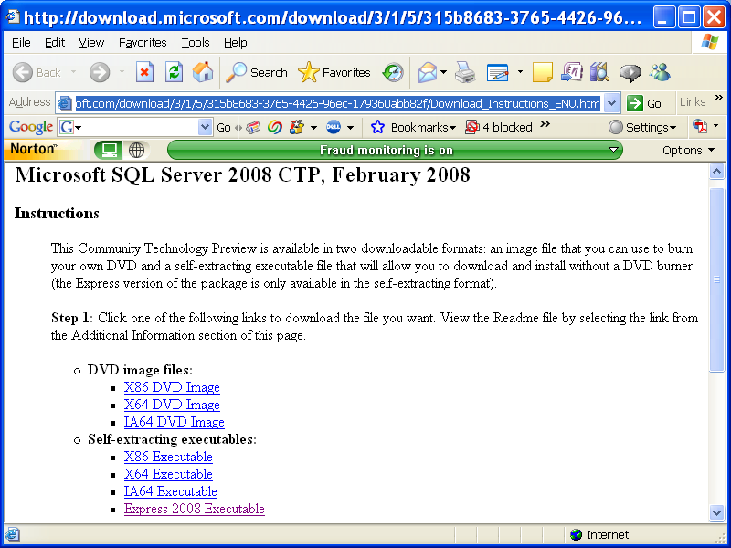
Click to download SQL Server 2008 EX

When the downloading starts, a dialog is displayed to ask your selection, either to save or directly install this software in your machine. In our case, we want to save the executable file first, and then install it in our machine. Click the Save button to begin to download SQL Server 2008 Express. Then you can install it by double clicking the download executable file SQLEXPR.exe and click the Run button to install it.
Click the Accept button to the license acknowledgement dialog, and then click the Next and Install buttons on the following two dialogs to begin to install SQL Server 2008 Express Community Technology Preview (CTP) in your computer.
The SQL Server Installation Center dialog is shown as below to allow you to make your desired selection.
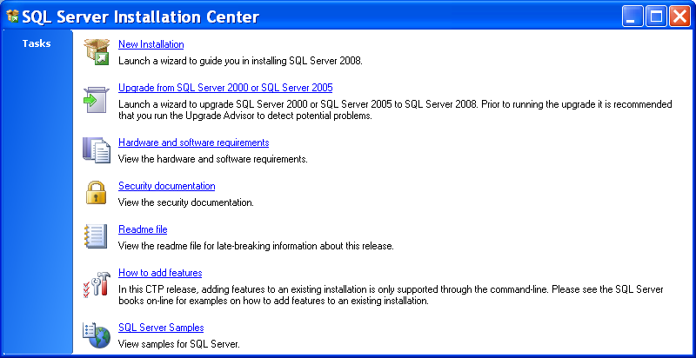

Click the New Installation if you have not installed any previous version of the MS SQL Server and want to install SQL Server 2008 Express in your computer. Otherwise, you can select Upgrade from SQL Server 2000 or SQL Server 2005 if you have already installed the related previous version of SQL Server. Other options are used to support this installation, such as the scanning and checking the hardware and software requirements, security issues, adding other features and some SQL Server samples.
In our case, we want to install a new version of SQL Server 2008 Express, therefore, click the first selection – New Installation.
Click Next button to the next dialog to open the Feature Selection dialog, which is shown below.

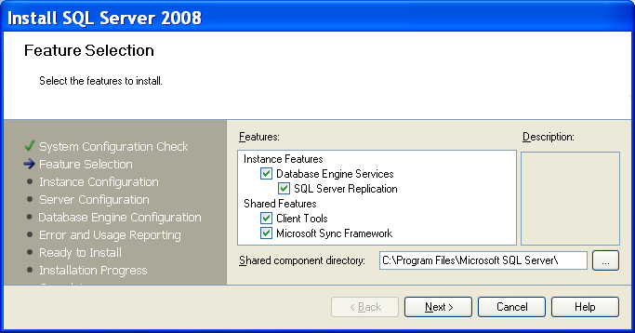

Of all these features, two of them are very important to us: Database Engine Services and Client Tools since we want to install both the SQL Server and SQL Client in our single machine. Basically, in order to use all features provided by the SQL Server 2008, select all features by checking all checkboxes. Click the Next to continue.
The next dialog is the Instance Configuration that allows you to select the default database instance or create a named database instance. For general applications, the default instance is good enough. Therefore let’s keep the default instance with the instance ID of SQLExpress unchanged, which is shown below.

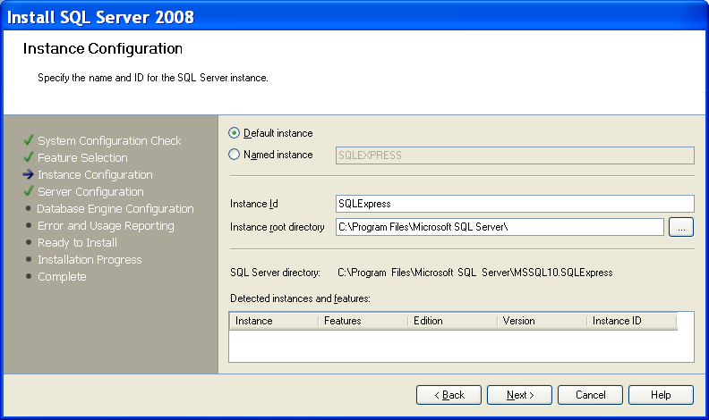

Click the Next button to go to the next dialog, which is the Server Configuration dialog shown in below.

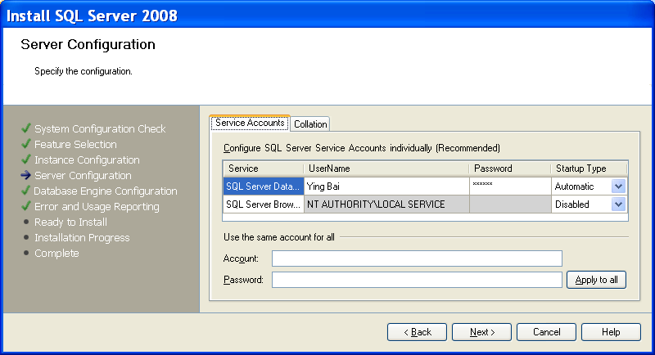

Enter the UserName and Password, which are exactly your window’s user name and password as you logon to this computer, into the UserName and Password boxes, as shown above. To check and confirm your UserName and Password, open the Control Panel|User Accounts, and then click the User Accounts icon under the or Pick a Control Panel icon. Select the desired user by clicking it to open the User Accounts dialog, which is shown below.

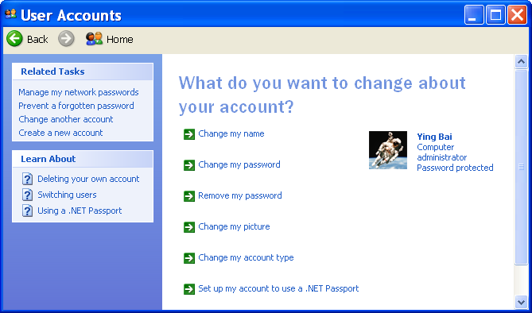

To check the UserName and the Password, click the Change my name and the Change my password items to get the preset UserName and Password, respectively. In our case, the UserName is Ying Bai and the Password is reback. Therefore enter Ying Bai into the UserName box and reback into the Password box. Click the Next button to go to the next dialog. Do not worry about the Account and Password boxes since we only have one account for our applications.
The next dialog is the Database Engine Configuration, which is shown below.

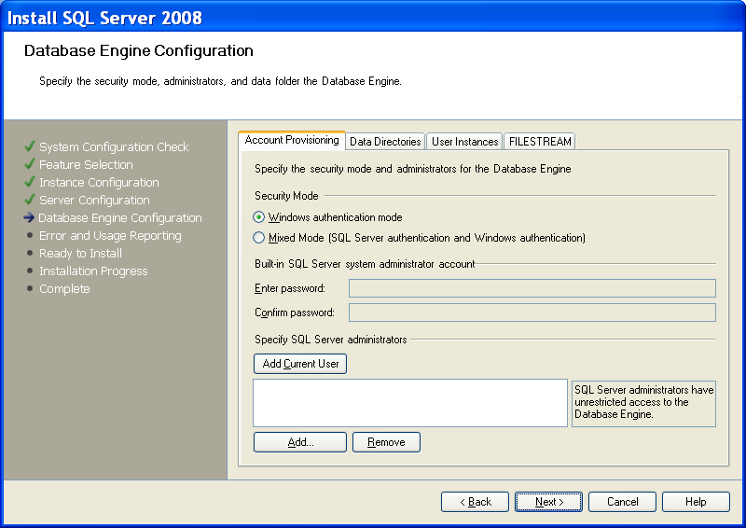
This dialog allows you to setup the Security Mode for the database security issue. For most general database applications, the Windows authentication mode is utilized for the Security Mode, therefore keep the default Security Mode unchanged. Also keep all other tabs unchanged since we want to keep those default settings for the Data Directories and the User Instances without any modification. But for the item: Specify SQL Server administrators, you must clearly indicate which user is this SQL Server administrator. For our applications, we like to use this computer administrator, Ying Bai, as this SQL Server administrator, too. To do that, click the Add Current User button to add the current user Ying Bai into the SQL Server administrator box, which is shown below and click the Next button to move to the next dialog.

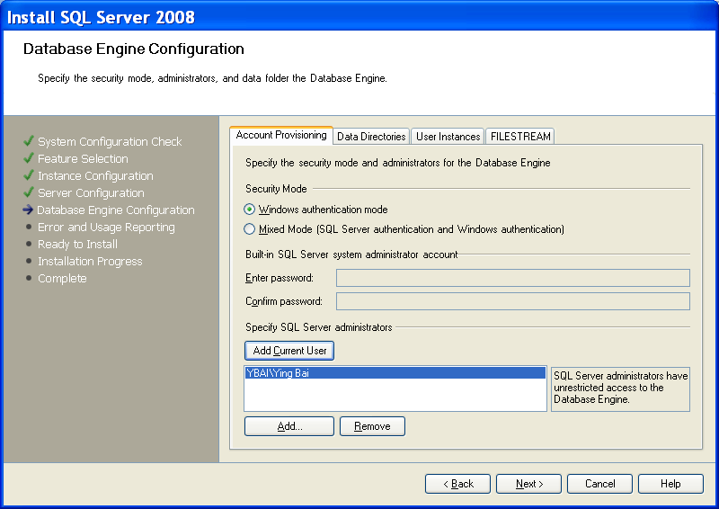

The next dialog is used to setup the Error and Usage Report for this database server, which is shown below.

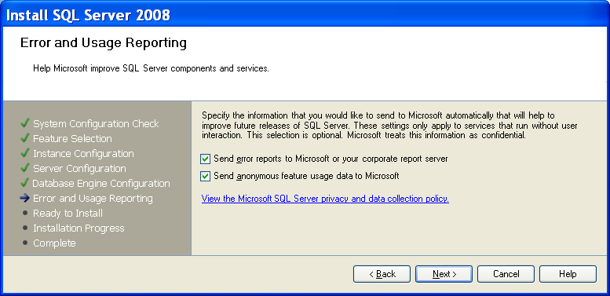

Since we want to use all of these error and usage report functionalities, so keep those default settings and click the Next to go to the next step.
One key point when perform the Server Configuration process is the UserName and Password, which must be identical with the current computer’s UserName and Password. More important, both items must be non-empty. This means that neither UserName nor Password can be blank. Some errors will be encountered during the Server Configuration process if one of items is empty since SQL Server 2008 is a security enhancement database and is very heavily dependent on the UserName and Password as one of the most important security criteria.
The next dialog is Ready to Install, which is shown below.

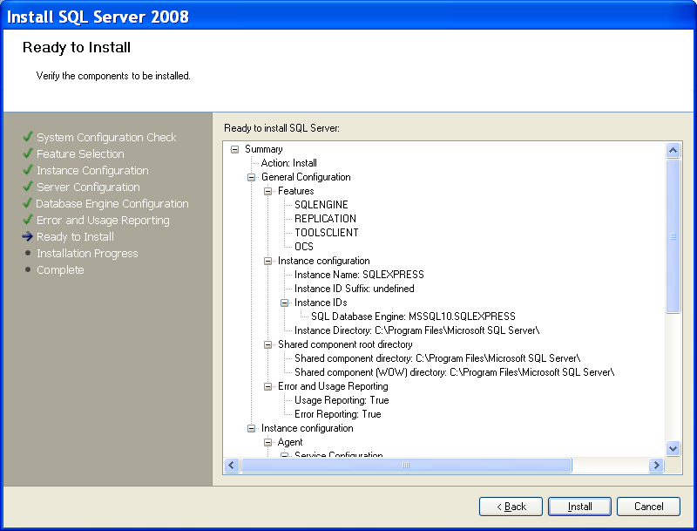

This dialog lists all features and components of SQL Server 2008 Express that will be installed in your machine. To begin this installation, click the Install button.
The installation process starts, which is shown below.

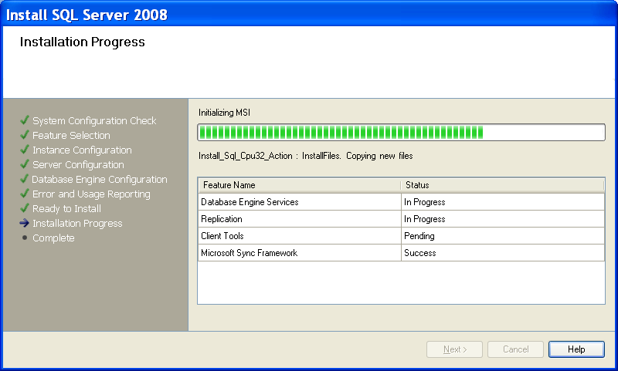

If the installation is successful, all of four components we selected at the beginning of this installation are installed in this machine, and the status for each component is indicated with Success, which is shown below.

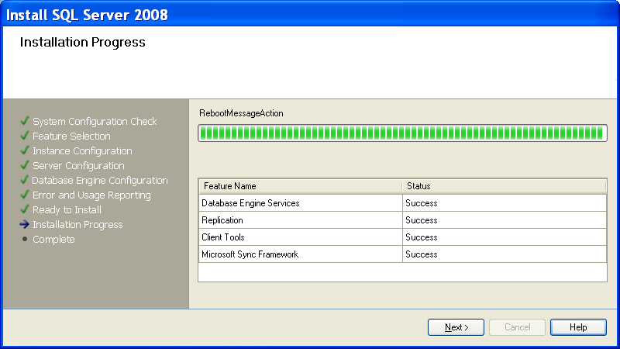

Click the Next button to go to the last step.
Finally the Completing the Microsoft SQL Server Installation Wizard page is displayed, which is shown below. You can view the Setup summary log by clicking the link provided on this page. To exit the SQL Server 2008 Installation Wizard, click Close.

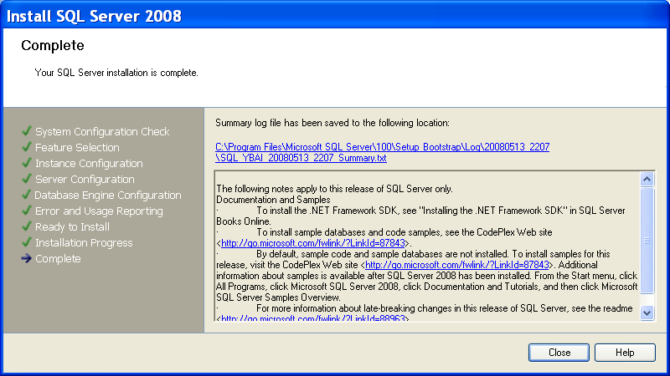

In this way, we finished the installation of SQL Server 2008 Express.

PART II Download and Install SQL Server Management
Studio Express

After finishing installation of SQL Server 2008 Express, you need to download and install SQL Server Management Studio Express to access and use SQL Server 2008 to create and manipulate databases. In order to do that, first you need to install .NET Framework 2.0 and above as well as MSXML6.0 Parser. Regularly, the .NET Framework 3.5 should have been installed in your computer if you have installed Microsoft Visual Studio.NET 2008. Similarly, if you have already installed SQL Server 2008 Express, the MSXML 6.0 Parser should have been installed, too.
To download and install SQL Server Management Studio Express Edition (SSMSEE), go to the site:
http://www.microsoft.com/downloads/details.aspx?FamilyId=C243A5AE-4BD1-4E3D-94B8-5A0F62BF7796&DisplayLang=en, and the download page is shown as below.

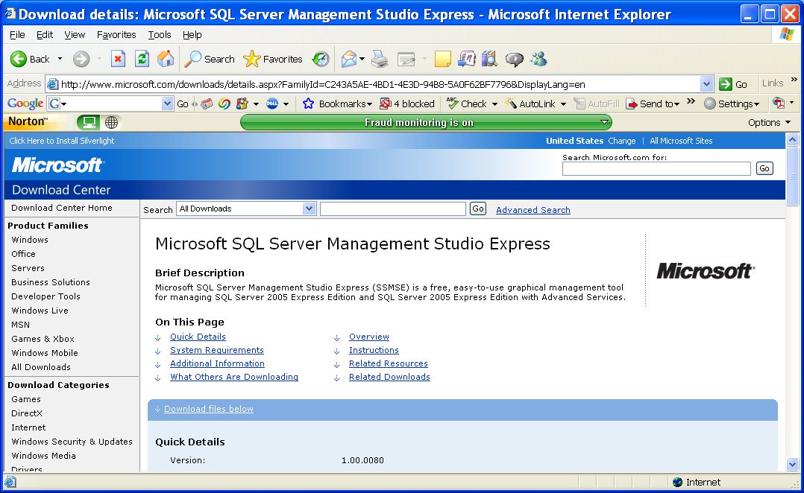

Scroll down along this page and you will find two files are available for this downloading, which are located under the Files in This Download:

File Name: | File Size
SQLServer2005_SSMSEE.msi | 38.5 MB | Download
SQLServer2005_SSMSEE_x64.msi | 39.0 MB | Download
The first file is for the 32-bit computer and the second one is for the 64-bit computer. For our application, click the Download button that is related to the first file, SQLServer2005_SSMSEE.msi.
Click the Save button to the popup dialog to begin this download. Generally we want to download this file into the Temp folder in the root drive, of course, you can download any desired folder if you like.
When the download is done, open the Windows Explorer and go to the Temp folder, then double click the downloaded file SQLServer2005_SSMSEE.msi and click the Run button to begin the installation.
Click the Next button and accept the license agreement, and enter your name and organization name to finish the registration process. The Feature dialog is displayed, which is shown below.

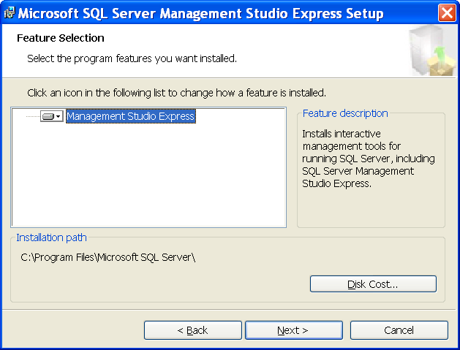

Keep the default selection and click the Next button to go to the next page.
Click the Install button to begin this installation. A successful installation dialog is displayed if this process is fine. Click the Finish button to close this dialog.

